Result of the Map1_with_barrier_6

Table

Map1_with_barrier
Angle degree | Robot_size | Route distance | Running time (s) | Coverage (%)
357 | 6 | 1908,47 | 60,14 | 71,68
358 | 6 | 1932,31 | 105,7 | 69,57
359 | 6 | 2089,14 | 49,68 | 74,02
0 | 6 | 2102,81 | 63,62 | 73,45
1 | 6 | 2048,61 | 54,49 | 76,06
2 | 6 | 1880,9 | 49,01 | 66,68
3 | 6 | 1970,52 | 49,1 | 71,9
43 | 6 | 2048,59 | 37,86 | 78,11
44 | 6 | 2086,06 | 39,74 | 77,08
45 | 6 | 2075,38 | 37,81 | 77,64
46 | 6 | 2111,36 | 40,69 | 78,51
47 | 6 | 1935 | 39,27 | 77,29
48 | 6 | 1980,92 | 44,95 | 78,55
87 | 6 | 2008,19 | 78,45 | 78,61
88 | 6 | 2101,57 | 72,08 | 75,8
89 | 6 | 2203,98 | 65,16 | 76,22
90 | 6 | 1970,31 | 69,45 | 76,37
91 | 6 | 2099,23 | 70,76 | 75,77
92 | 6 | 2082,79 | 65,31 | 79,43
93 | 6 | 2144,66 | 71,2 | 77,27
133 | 6 | 1923,62 | 39,34 | 76,71
134 | 6 | 1858,71 | 43,62 | 75,94
135 | 6 | 2123,98 | 66,75 | 75,87
136 | 6 | 1944,85 | 45 | 76,96
137 | 6 | 1960,12 | 39,1 | 77,11
138 | 6 | 1986,87 | 43,73 | 78,63
177 | 6 | 2108,23 | 56,64 | 72,29
178 | 6 | 1837,58 | 89,46 | 70,17
179 | 6 | 1928,22 | 73,67 | 72,95
180 | 6 | 1976,35 | 115,89 | 73,13
181 | 6 | 1903,47 | 60,9 | 75,52
182 | 6 | 1708,95 | 77,62 | 66,3
183 | 6 | 1961,88 | 55,69 | 70,57
223 | 6 | 2002,96 | 39,16 | 78,14
225 | 6 | 2202,62 | 37,8 | 80,73
267 | 6 | 2154,67 | 138,07 | 78,43
268 | 6 | 2166,65 | 107,45 | 78,58
269 | 6 | 2109,56 | 78,89 | 76,2
270 | 6 | 2095,98 | 95,39 | 76,16
271 | 6 | 2166,54 | 110,61 | 76,35
272 | 6 | 1924,52 | 65,55 | 78,33
273 | 6 | 2309,52 | 108,62 | 78,27

Blue color is the best result.
Red color is the best Horizontal/Vertical.
Green color is the Best approximate vertical/horizontal angle degrees.

Best horizontal/vertical
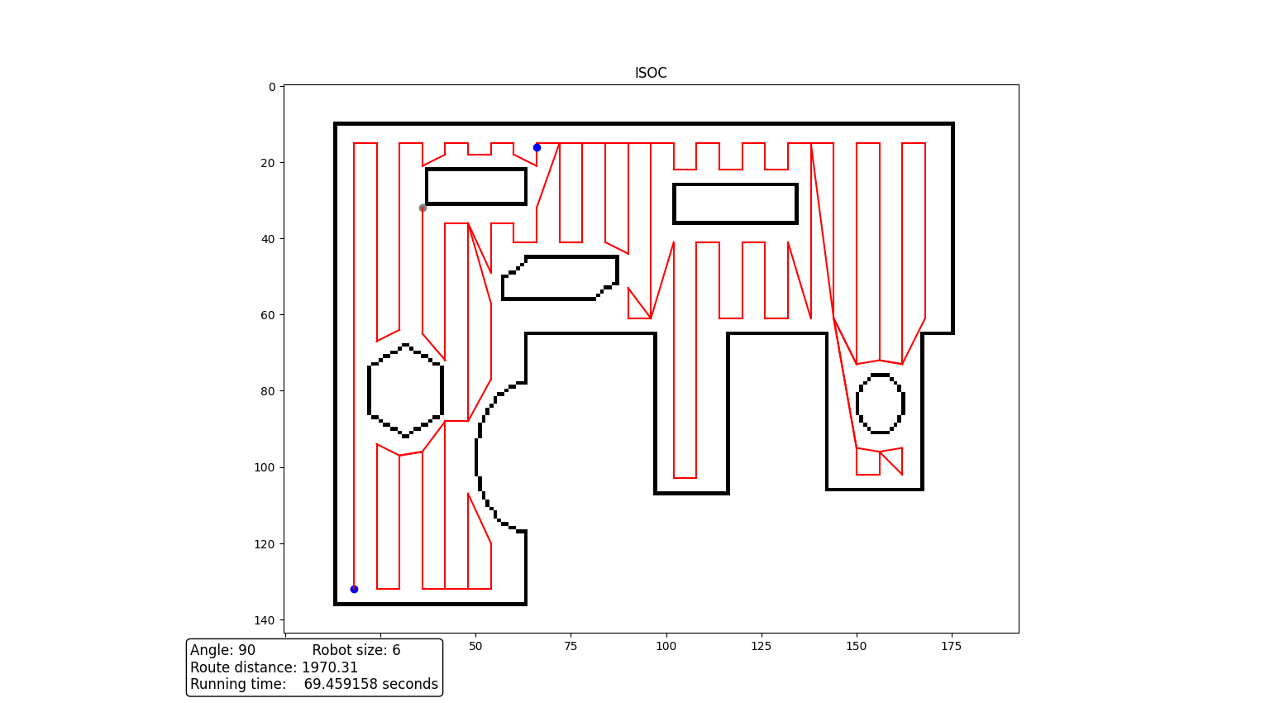
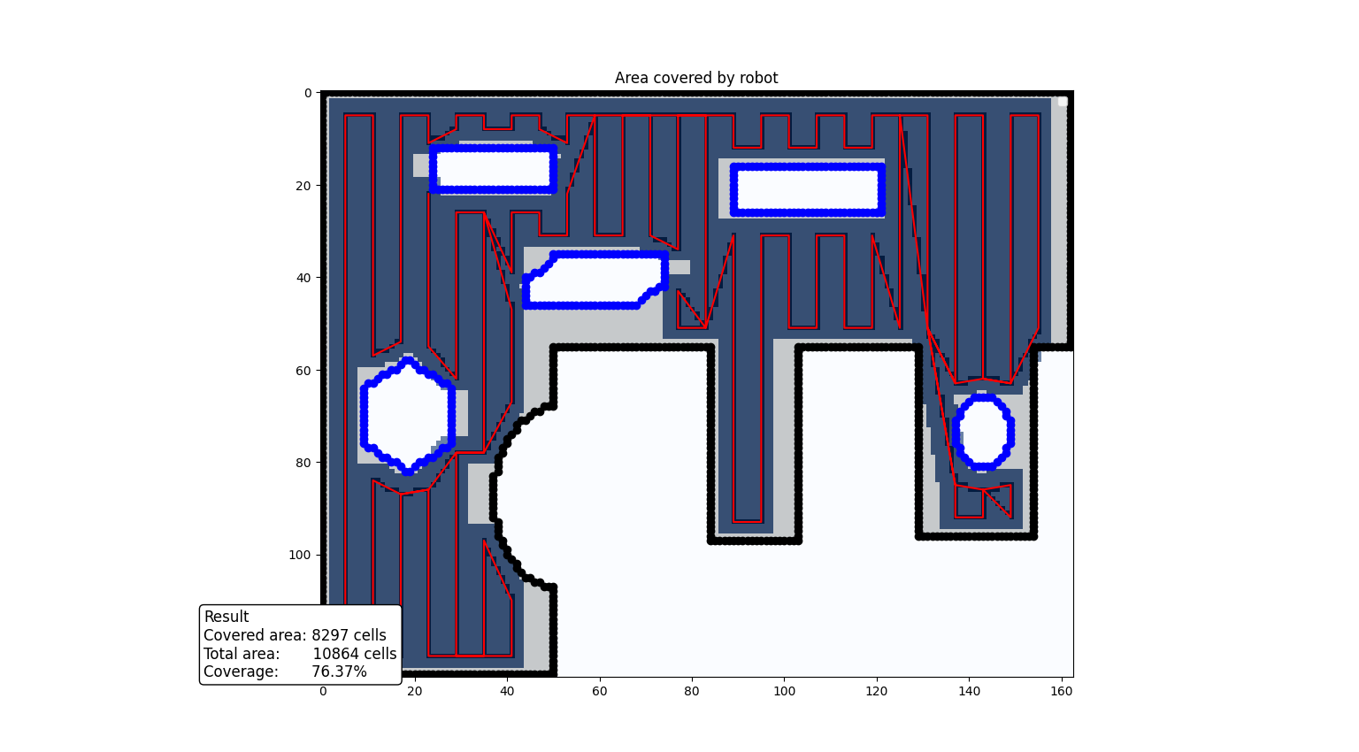


Best approximate vertical/horizontal angle degrees
